UNHM MATH 422 Exam #1 NAME______________________________________________

Date_____________________________________

PLEASE REMEMBER:  Show your reasoning and/or math work in every problem. Some questions have more than one part. Make sure you answer every part of the question that was asked. You are being asked to calculate some things and interpret others.

1. (4 pts)

The total cost *C(x)*, in dollars, to produce *x* items is given by the function graphed below.

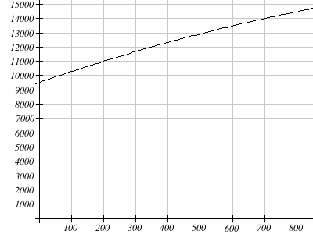

Find the average cost per item (the average rate of change) when increasing production from 200 units to 700 units.

Show your work here:

UNHM MATH 422 Exam #1 Page 2/7

2. (4 pts)

You have estimated the cost function for producing $x$ items is given by

$y=C\left(x\right)=31200+15x$. (Assume you are selling as many items as you are producing.)  
  
a) Find the cost of producing 300 items.  
  
b) How many items can be produced with a budget of $65,000? (You may use the graph below to help with this question)  
  
  
Show your work here:

3. (4 pts) This graph shows cost C(x) as in question #2. There is another graph for revenue (the line that starts at (0,0)).

Cost and Revenue


cost

revenue

What is the break-even point between cost and revenue?

UNHM MATH 422 Exam #1 Page 3/7

4. (4 pts)

The value of business furniture is assumed to depreciate (decrease) in value linearly.  The value was $44,000 when it was purchased in 2012 and $37,100 in 2015.

1. ***Find an equation*** for the value of the furniture. Let y = the value, x = years after 2012

b) In what year will the value drop below $28,000?

Show your work here:

Remember, y = mx + b, where b = (0,b) and $m=\frac{Δy}{Δx}=(y_{1}-y_{0})÷(x_{1}-x_{0})$

UNHM MATH 422 Exam #1 Page 4/7

5. (4 pts)

Suppose the quantity demanded, *x,* of a product when the price is *y* dollars is given by the equation $y=950-2x$   , and the quantity supplied is given by the equation $y=200+3x$

a) Sketch the supply and demand curves

b) Find the equilibrium **price** and **quantity**. Price ______________ Quantity ______________

Show your work here:

UNHM MATH 422 Exam #1 Page 5/7

6. (4 pts)

A **regression** (line of best fit) was run to determine if there is a relationship between hours of TV watched per day (*x*) and the number of sit-ups an average person can do (*y*).  The results were:

y = mx+b  
slope (m) = -0.79  
y-intercept (b) = 23.85

1. If a person watches 19 hours of television a day, predict how many sit-ups they can do.
2. How many sit-ups can a person do if they watch **no TV** at all?

7. (4 pts)

What is the range of $f\left(x\right)=\sqrt{4+6x}$ with x in [2, 192]

$\sqrt{2}≤y≤\sqrt{192}$

$4≤y≤34$

$y≥0$

$y≥\frac{-2}{3}$

UNHM MATH 422 Exam #1 Page 6/7

8. (4 pts)

Based on the table below,

|  |  |  |  |  |  |  |  |  |  |  |
| --- | --- | --- | --- | --- | --- | --- | --- | --- | --- | --- |
| $$x$$ | 0 | 1 | 2 | 3 | 4 | 5 | 6 | 7 | 8 | 9 |
| $$f\left(x\right)$$ | 57 | 28 | 86 | 4 | 25 | 93 | 71 | 5 | 48 | 56 |

a. Evaluate $f\left(5\right)$ Answer: $f\left(5\right)$ =   
  
b. Solve $f\left(x\right)=4$ Answer: =

9. (4 pts)

When , evaluate   
  
  

10. (4 pts)

Find the domain and range of the function graphed below. Give your answer as an interval, or use a double inequality.  
  
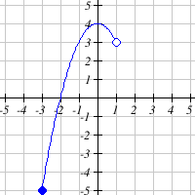  
  
Domain:  Range:

UNHM MATH 422 Exam #1 Page 7/7

11. (4 pts)

Write an equation for the graph below in terms of $x$. Lines are y = mx+b  
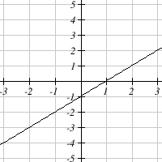

12. (4 pts)

Solve the system of linear equations: 3x + 4y = 28

You may use Excel x – 8y = 0